

NORTH SOUTH UNIVERSITY

Department of Electrical & Computer Engineering

**Fall 2017**

# EEE 311

*Project Report*

Project Title: Earthquake Dictator Circuit

Section: 05

Deadline for submission: 20/12/2017

Group Members:

|  |  |
| --- | --- |
| **Name** | **Student ID** |
| *Wordh Ul Hasan* | *1330471642* |
| *Syed Rafid Hassan* | *1510472043* |
| *Mohmmad Jahidul Islam* | *1611139043* |

***Table of Contents***

|  |  |
| --- | --- |
| ***Topic*** | ***Page*** |
| Introduction | 1 |
| Basic Block Diagram | 1 |
| Simulation Snapshot | 3 |
| Functionality | 4 |
| Challenges and Remarks | 9 |
| Circuit Prototype | 10 |
| Equipment list and Budget | 12 |
| Summary and Conclusion | 13 |
| Future Work | 13 |
| Market Application | 13 |

***Introduction***

Here is an ultra sensitive earthquake detector circuit that can sense seismic vibrations.It can be used to detect vibrations in the Earth. So it is an ideal device to monitor entry passages. The circuit exploits the direct piezo electric property of the piezo element used in buzzers.The Lead Zirconate crystals present in the piezoelement can readily store current and can release the current when the orientations of the crystals are disturbed through mechanical vibrations. IC1 amplifies the signals from the piezo element and the high output from IC1 switches on T1. When T1 conducts, trigger pin 2 of the monostable (IC2) will grounded to give 3 minutes high output.

***Basic Block Diagram***

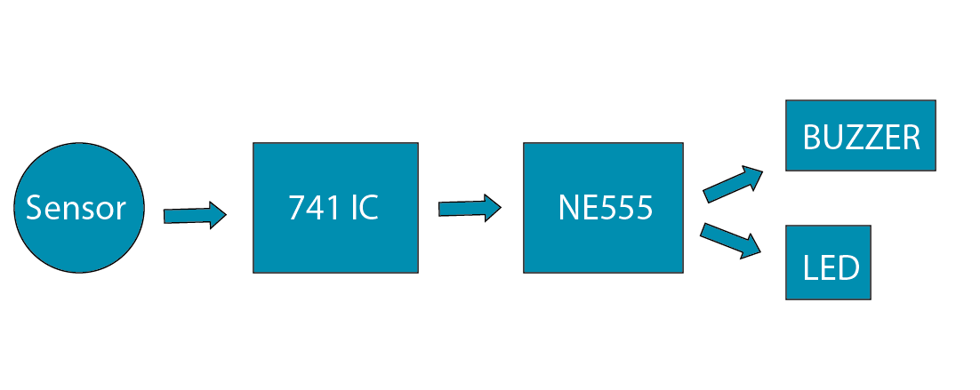

 The main components in this project are the 555 Timer,Op-Amp and the BC557 NPN transistor.

***Simulation Snapshot***

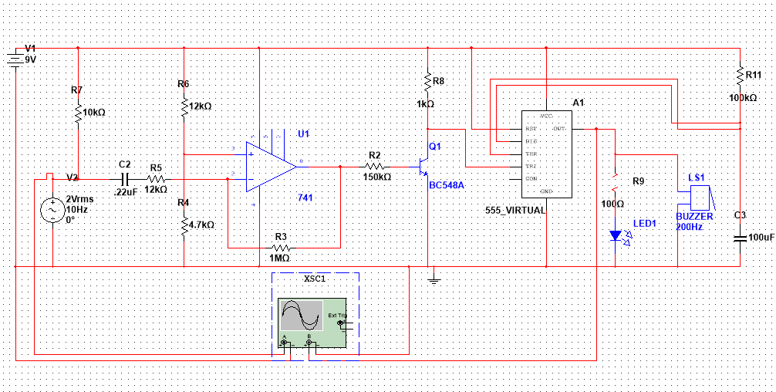

***Fig: Multisim Simulation***

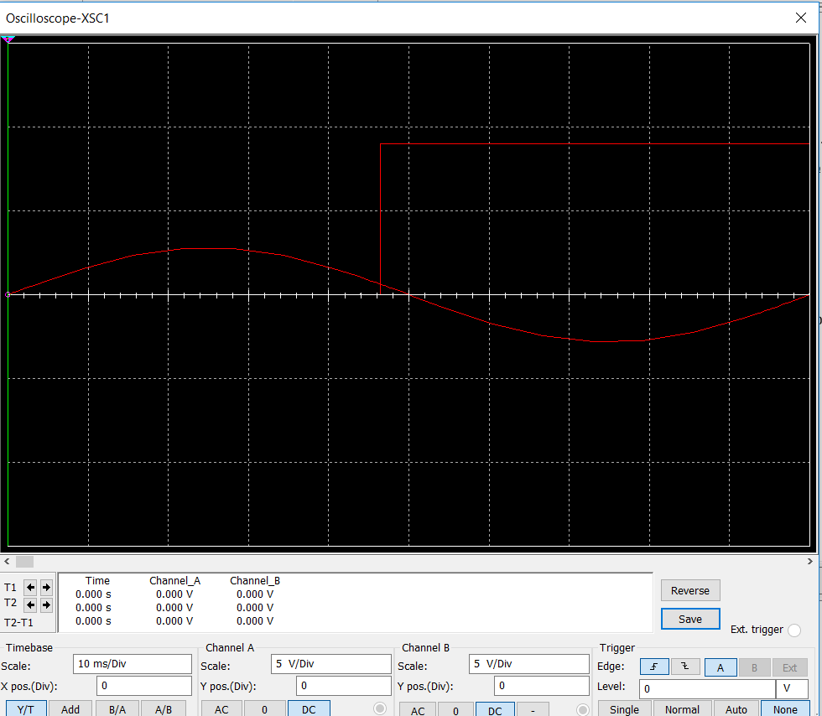

***Fig: Multisim output***

***Functionality***

Piezo Element is a type of sensor which has electro-mechanical principle. That means it converts the mechanical data into current. Input is mechanical here and output is electricity. Here this Piezo, 7BB-20-6CLO is a vibration detector. it works with Op-amp, 741; Timer, 555; and NPN BJT, BC 548 here. The function is like when the piezo get the vibration from the surface it opens the current path and showing its output on 9v Buzzer and LED. Basically it can be called as an Earthquake Detector. The electrolytic capacitor is for storing the charge by the mean of time. The output time is depending on the value of the capacitor. That means the discharging time. The tantalum capacitor is working as a filter of the circuit which cancel out the noise on the frequencies. The trimmer POT is working with the sensitivity of the piezo. When value is higher the sensitivity goes 0. So it should be set to an optimum value. BJT works like a trigger here, which supply the output to the timer. Op- amp is for amplifying the signals Timer is for the final oscillation.

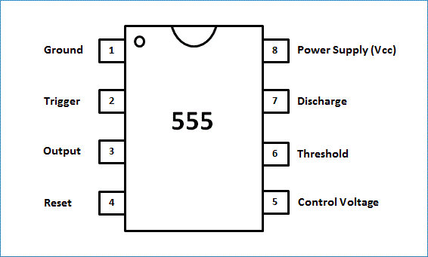

***555 Timer Pinout***

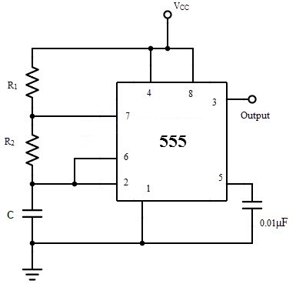

***External Connections for 555 timer***

The time period and frequency of the output waveform can be determined by the following formulae:

**Time High** (Seconds) T1 = **0.693 * (R1+R2) * C1**

**Time Low** (Seconds) T2 = **0.693 * R2 * C1**

**Time Period** T = Time High + Time Low = **0.693 * (R1+2*R2) * C1**

**Frequency** f = 1/Time Period = 1/ 0.693 * (R1+2*R2) * C1 = **1.44 / (R1+2*R2) * C1**

**Duty Cycle** = T1/(T1+T2)

The output waveform produced appears as such:

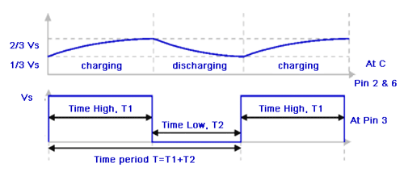

***Timing diagram for 555 timer in astable mode***

In our case the value for R1 = 1000ohm and R2=440000ohm and C1=0.000001F. So using these formulae we can calculate our values to be:

|  |  |  |  |  |  |  |  |
| --- | --- | --- | --- | --- | --- | --- | --- |
| **R1(Ohm)** | **R2(Ohm)** | **C1(F)** | **Time High(s)** | **Time Low(s)** | **Time Period(s)** | **Frequency**  **(Hz)** | **Duty Cycle** |
| 1000 | 440000 | 0.000001 | 0.305613 | 0.30492 | 0.610533 | 1.63791 | 0.50057 |

Once the connection is made power the circuit, the brake cable is connected across the +5V and base of BC557 through a resistor as shown in the circuit previously.

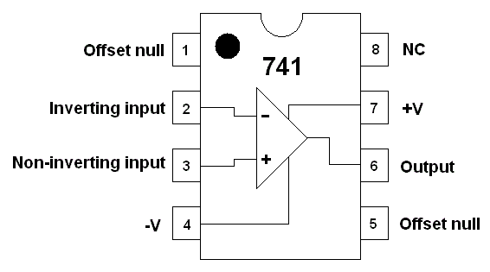

**Fig:LM741 Op-Amp**

Pin configuration of IC 741 op amp is shown above

* Pin 1 is Offset null.
* Pin 2 is Inverting input terminal.
* Pin 3 is a non-inverting input terminal.
* Pin 4 is negative voltage supply (VCC)
* Pin 5 is offset null.
* Pin 6 is the output voltage.
* Pin 7 is positive voltage supply (+VCC)
* Pin 8 has no connection.

The 741 op-amp is used in two ways such as an inverting and a noninverting

#### An Inverting Amplifier

In an 741 op amp  IC pin2 is the input pin and pin6 is the output pin. When the voltage is applied through the pin2 then the output comes from the output pin 6. If the polarity is positive at the input pin2, then the polarity which comes from the output pin6 is negative. So the output is always reverse to the input.

[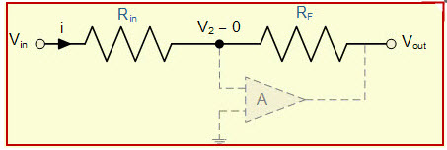](http://www.efxkits.co.uk/wp-content/uploads/2015/02/Inverting-Operational-Amplifiers.jpg)

Inverting Operational Amplifiers

The basic circuit of an inverting amplifier is shown and the gain of this circuit is simply calculated by the following formula

                                                             A=-Rf/R1

For instance, if Rf is 1000 kilo ohm and R1 is 100 kilo ohm then the gain would be -1000/100=-10 If the i/p voltage is 1.5v the o/p voltage would be 1.5x-10=15

#### Non Inverting Amplifier

In an op-amp 741 IC pin3 is the i/p pin and pin6 is the o/p pin. When the voltage is applied through the pin3 then the output comes from the output pin 6. If the polarity is positive at the input pin3, then the polarity which comes from the output pin6 is also positive. So the output is not inverted.

[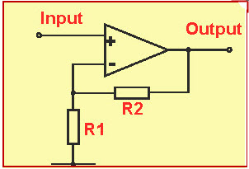](http://www.efxkits.co.uk/wp-content/uploads/2015/02/Non-Inverting-Amplifie.jpg)

Non-Inverting Amplifier

The basic circuit of noninverting amplifier is shown and the gain of this circuit is simply calculated by the following formula A=1+ (Rf/R1)

***Challenges faced and remarks***

The main challenge I faced while doing this project was finding proper components. The .22uF capacitor is not available at Techshop or any local shop. I had to borrow it from the Laboratory of NSU.

The Circuit is set up accordingly but I did not get the expected output. I did the simulation accordingly and in the simulation I do get a proper result but in the actual circuit the expected output has not been met.

Chekced by reconstructing the circuit several times. Initial thought was the the Sensor is faulty but made another circuit to check the sensor output and it works so the main fault by analysis of the circuit is that with the capacitors.

.

***Circuit Prototype***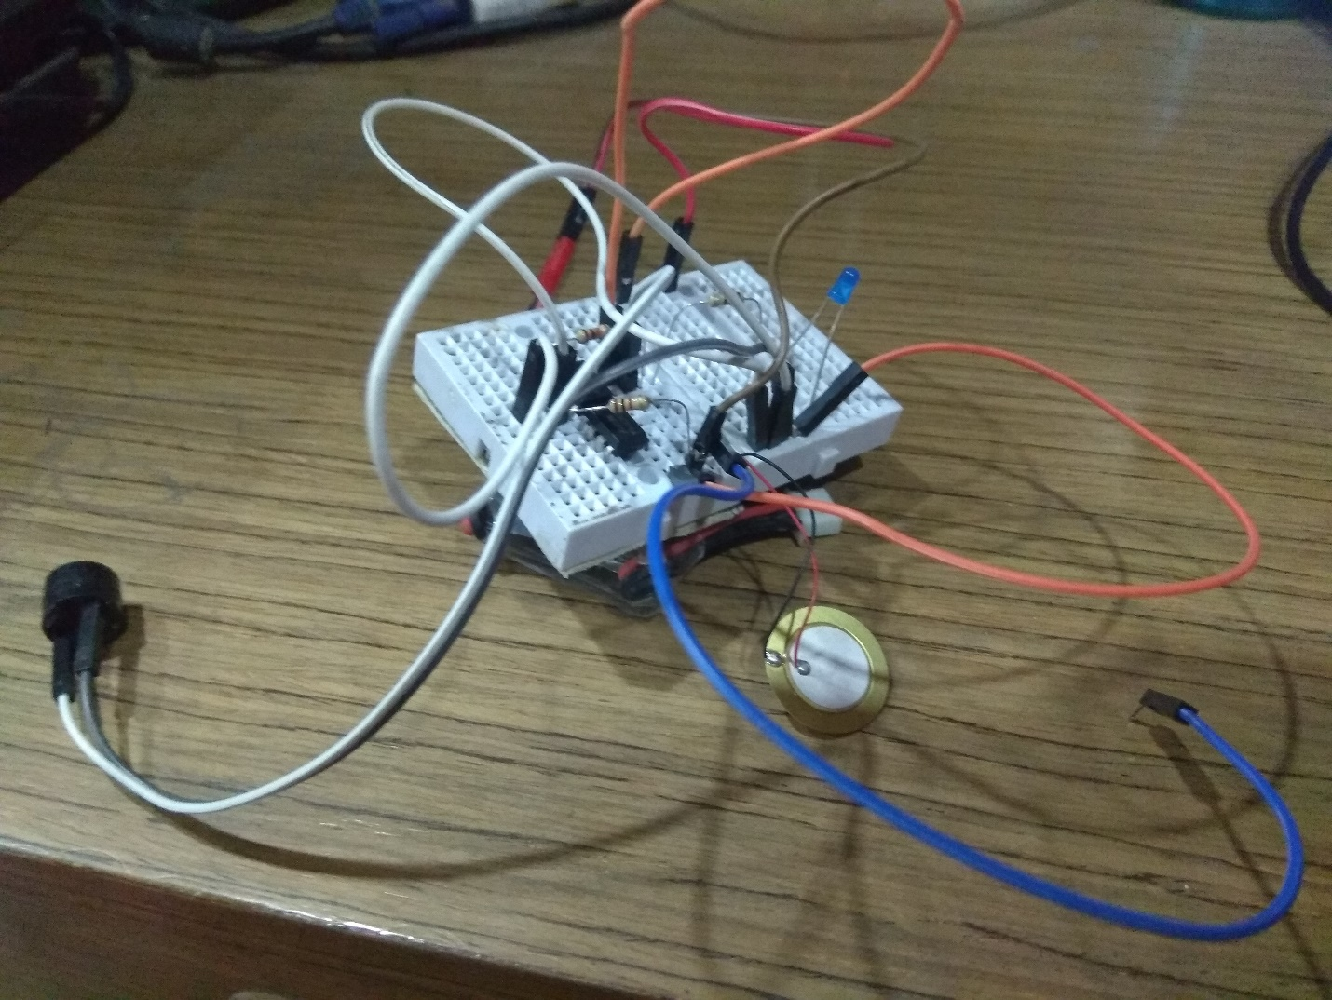

***Photo of the Project Circuit***

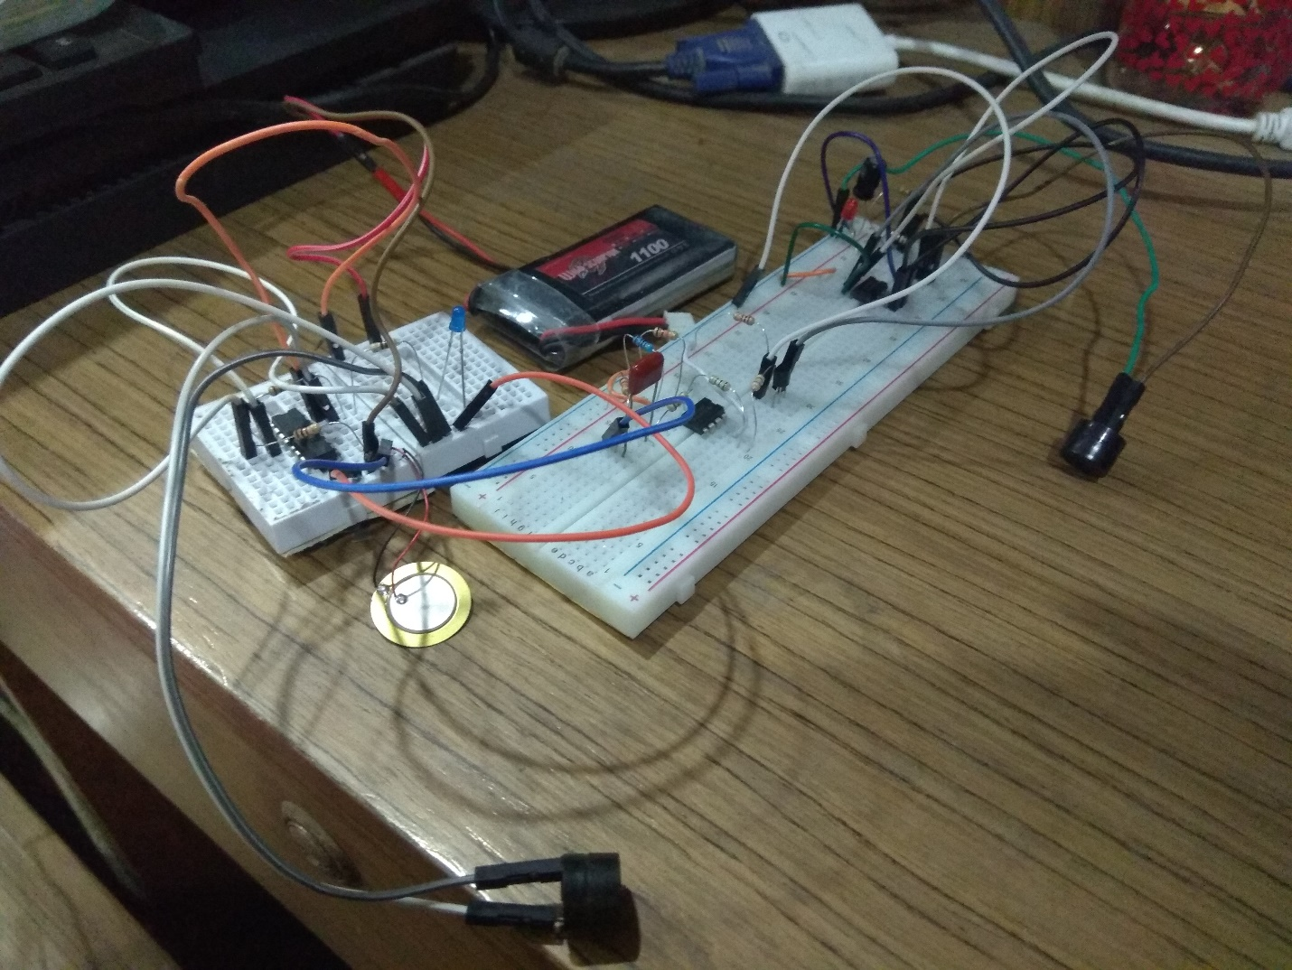

***Equipment List and Total Budget***

|  |  |  |
| --- | --- | --- |
| ***Component*** | ***Quantity*** | ***Price*** |
| *Breadboard* | 1 | 105.40 |
| *555 timer* | 1 | 36.00 |
| *Op-Amp* | 1 |  |
| *Jumper Wires* | 20 | 43.20 |
| *Buzzer* | 2 | 33.70 |
| *BC557 NPN Transistor* | 10 | 18.90 |
| *LED(red)* | 10 | 13.90 |
| *LED(green)* | 10 | 13.90 |
| *1uF Capacitor* | 10 | 11.40 |
| *0.1uF Capacitor* | 2 | 10.00 |
| *Resistors (440K, 1K)* | (bulk) | 35.00 |
| *Battery 9V* | 1 | 50.10 |
| *Battery Connector* | 1 | 7.02 |
| *LM7805 Voltage Regulator* | 1 | 10 |
| *Total* | - | 384 BDT Only |

***Summary and Conclusion***

If everything is to work as expected, the buzzer and red LED should be turned Off. After detecting the signal from the sensor the Red LED and the Buzzer should start flashing.

But unfortunately this is not the case for our project. Thought theoretically our project should work and does work In the Multisim Simulation it does not work in real life due to faulty components.

***Future Work***

As the circuit can detect earthquake in future we can add some IOT modules like ESP826 to connect it to the server and record regular activities and movement data and try to find a pattern in them. We can also make and android app which will get the instant update if earthquake starts happening.

***Market Application***

Currently after the earthquake starts it takes minimum 30 to 50 seconds for some people to be sure that yes truly earthquake is happening and then they start panicking. The first thing people try to look to make sure if it’s an earthquake or not is to concentrate the fan movement and nearby water movement. Stares at them for 3 to 4 seconds to be sure about earthquake but if this project is implemented people will no longer need to make sure as the alarm goes on people should be aware the earthquake is happening and during this time every microsecond and the actions we take in those seconds matter. These can be used in houses, factories, Industries for safety measure.